Hailsham Avenue, Longbenton, Newcastle upon Tyne. NE12 8FD Tel: (0191) 643 2730 Fax: (0191) 643 2731
Email: office@bentondeneschool.co.uk www.bentondeneschools.org.uk

12 January 2021

Dear Parents/ Carers,

Thank you once more for all the support you have given, and the positive comments received, regarding the opening of school since the beginning of term. All staff are working extremely hard to ensure that school is as safe as it can be for both pupils and staff during the current lockdown period.

I am writing to make you aware that we will be required to close early each Friday.

On a Friday, pupils will have their lunch and then leave the site at 12.30pm or 12.40pm each week until further notice. This will start from Friday 15th January 2021. Please note that school hours will remain the same on Mondays to Thursdays.

This is to support planning and preparation time for our teaching staff: a statutory requirement. We are unable to facilitate this in the way that we would normally do as we have tightened our restrictions on mixing bubbles. Previously, we had teachers who moved across different classes during the day but in the interests of everyone’s safety we are limiting the number of staff who cross bubbles.

I have contacted school transport for North Tyneside and they are able to pick children up at 12.30pm and 12.40pm to facilitate this

I appreciate that this may cause difficulty for you as parents and carers but I hope you understand that we are trying our very best to create the safest environment for both our pupils and staff.

Thank you again for your support.

Take care and stay safe,

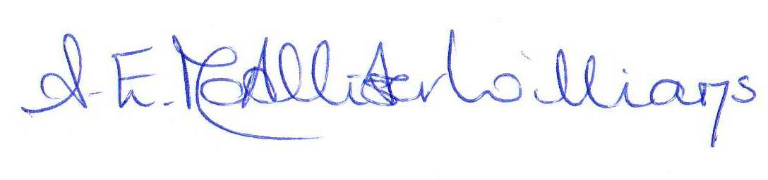
Alison McAllister-Williams
Headteacher
Benton Dene School

